**Wellbeing Resources for Parents**

*During this difficult time of school closures, please find below advice and resources that will help you to help your child to continue to learn at home.*

*We have also included links for general mental health information and guidance to help maintain wellbeing at this time of concern and anxiety for your family and our community.*

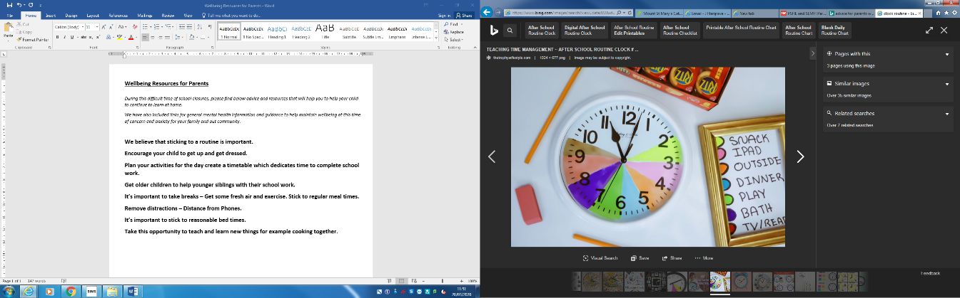

**We believe that sticking to a routine is important**

**Encourage your child to get up and get dressed**

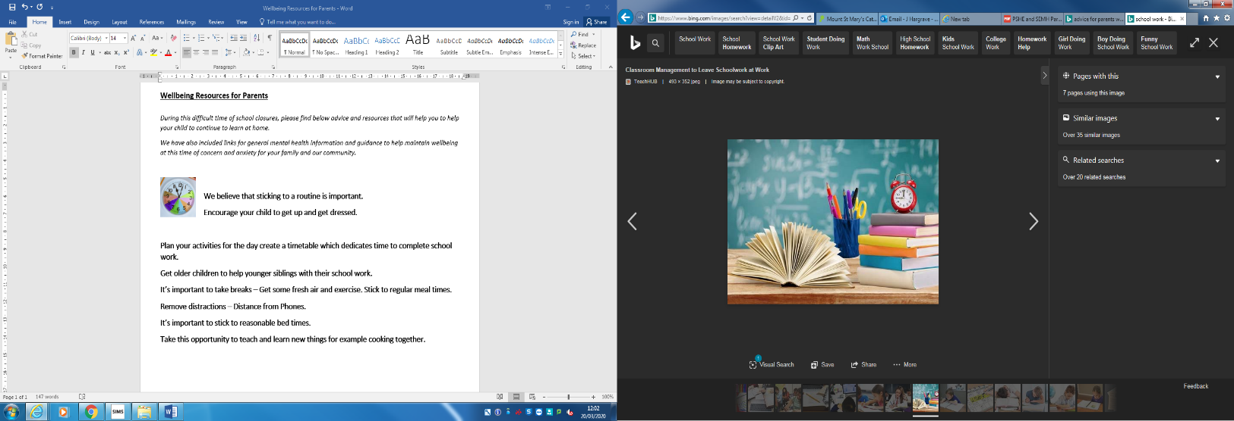

**Plan your activities for the day create a timetable which**

**dedicates time to complete school** **work**

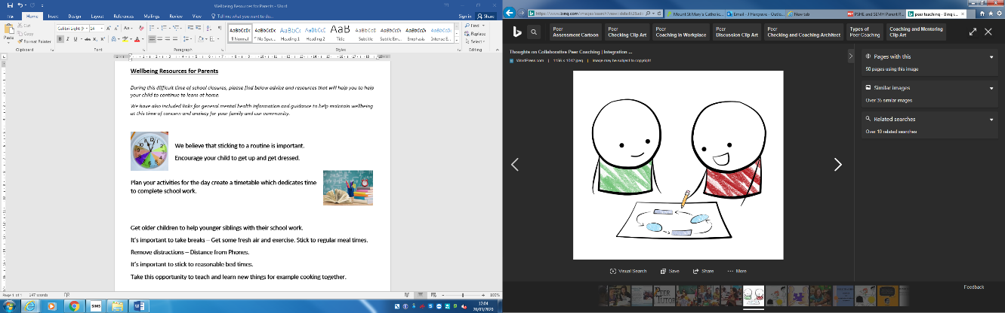

**Ask older children to help younger siblings with their school work**

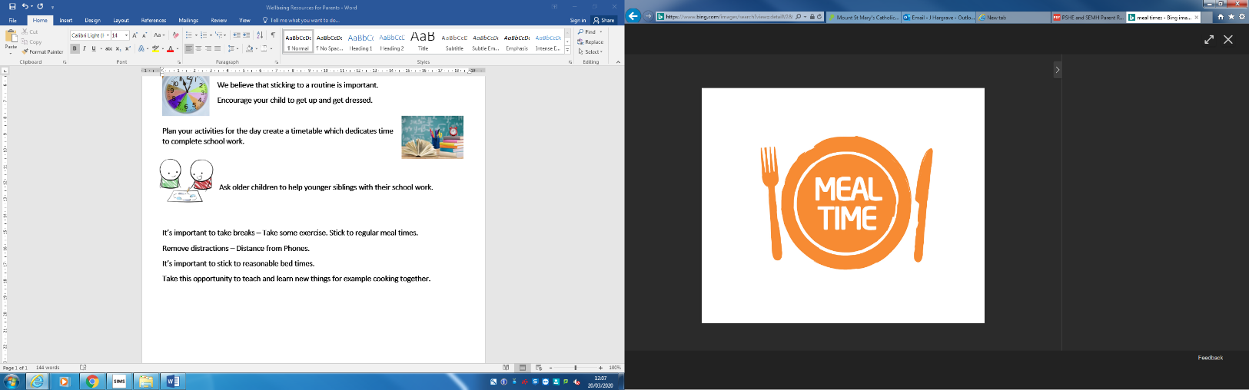

**It’s important to take breaks – Take some exercise. Stick to regular meal times.**

[**change4life**](https://www.nhs.uk/change4life)[**British Heart Foundation**](https://www.bhf.org.uk/informationsupport/support/healthy-living/healthy-eating)

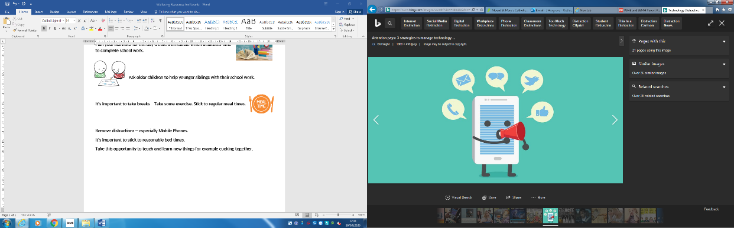

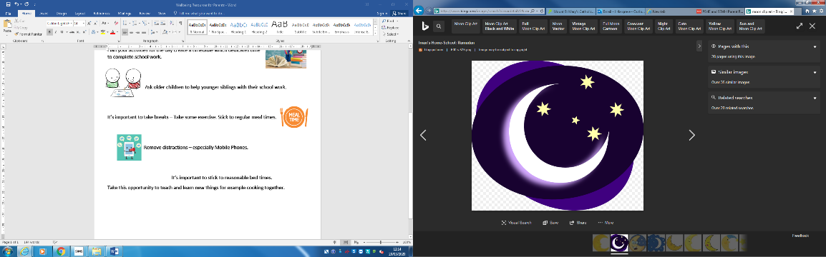  **Remove distractions – especially Mobile Phones**

**It’s important to stick to reasonable bed times**

**Take this opportunity to teach and learn new things for example cooking together**

[**NHS Eat Well Live Well**](https://www.nhs.uk/live-well/eat-well/)

Google Arts & Culture teamed up with over 500 museums and galleries around the world to bring anyone and everyone virtual tours and online exhibits [Google Arts and Culture](https://artsandculture.google.com/partner?hl=en)

20 Minute activities that you and your child can both enjoy and create a relaxed space to start a conversation [Youngminds 20-activities-for-20-minutes](https://youngminds.org.uk/starting-a-conversation-with-your-child/20-activities-for-20-minutes/)

**General Mental Health Information and Guidance:**

[**mind.org.uk information-support coronavirus**](https://www.mind.org.uk/information-support/coronavirus-and-your-wellbeing/?utm_medium=organic&utm_source=twitter&utm_campaign=info&utm_content=coronaviruswellbeing)

[**Mindwell-leeds.org.uk information-on-coronavirus**](https://www.mindwell-leeds.org.uk/home/information-on-coronavirus)

[**Mind Mate to help support young people**](https://www.mindmate.org.uk/)